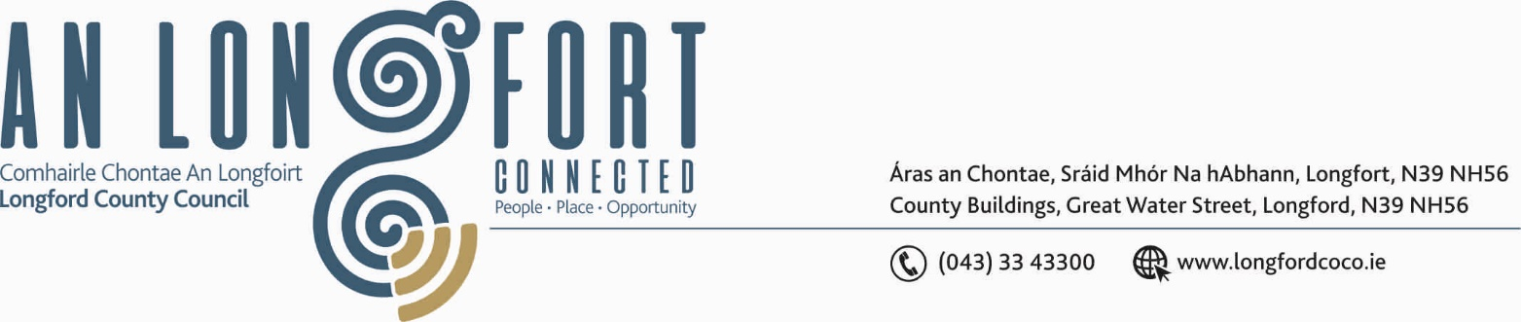

LONGFORD MUNICIPAL DISTRICT

21st November 2019.

To: Each Member of Longford Municipal District.

Dear Member,

You are requested to attend Meeting of Longford Municipal District to be held in the
Council Chamber, Town Hall, Market Square, Longford, on Wednesday,
27th November 2019 at 4.30 p.m. to transact business, as set out on the Agenda hereunder.


Yours sincerely,

_______________
Anne Lee,
Meetings Administrator.

AGENDA

Prayer before meeting.

- Confirmation of Minutes of Longford Municipal District Meetings held on the
23rd October 2019 – copies enclosed.

- Matters arising from Minutes.

- Declaration of Interest by Members.

- Management Report - to follow.

- Longford Town Community CCTV.

- Update on infrastructure for the Disabled in Longford Town.

- Consideration of the Taking in Charge of Castle Park, Newtownforbes, Co. Longford
(4 houses) - details enclosed.

- Consideration of the Taking in Charge of Clonguish Court, Newtownforbes, Co. Longford
- details enclosed.

- Notices of Motions, submitted by Councillors, as listed hereunder –

Councillor John Browne.

“ I call on Longford County Council to have drainage works carried out on the second green area in College Park, so as to stop water spilling out onto the pathways and onto the roadway, and making it easier on machinery to cut the grass.”

- A.O.B.



